**Smart Home Automation System with Parental Control Features**

**Your Name**: []

**Date**: []

# Abstract

This report discusses the design and development of a smart home automation system that integrates a robust parental control for IoT devices at home. The discussed system argues various issues on security, privacy, and child safety through enabling parents to monitor or bar children from various online activities, thus securing the communication across the devices. This project is based on a prototype built using Flask for the backend and Vite React for the frontend. The literature review was done to understand the existing challenges in the domain, including parental control system design, vulnerabilities due to IoT, and ethical issues. The testing was done through automated tools and sessions of user feedback. Based on that, some key findings that cropped up are the requirement of advanced reporting mechanisms in parental control and the use of privacy-preserving techniques in monitoring children's online activities. Discussion: The discussion points out where the system is going well and what could be improved in future versions. The last section concludes with recommendations toward the expansion of the system to more devices and improved security.

T**able of Contents**

[Abstract 2](#_Toc176652981)

[Introduction 4](#_Toc176652982)

[Background 4](#_Toc176652983)

[Literature Review 8](#_Toc176652984)

[Background on Smart Home Automation 8](#_Toc176652985)

[Integration of Parental Control Features in Smart Home Systems 11](#_Toc176652986)

[Comparative Analysis with Existing Solutions 11](#_Toc176652987)

[Methodology 14](#_Toc176652988)

[Prototype Development 14](#_Toc176652989)

[Backend Development 14](#_Toc176652990)

[Frontend Development 15](#_Toc176652991)

[Integration 15](#_Toc176652992)

[System Architecture 15](#_Toc176652993)

[Frontend: 16](#_Toc176652994)

[Backend: 16](#_Toc176652995)

[Database: 16](#_Toc176652996)

[System Architecture Diagram: 17](#_Toc176652997)

[User Testing 17](#_Toc176652998)

[Preparation: 17](#_Toc176652999)

[Testing: 18](#_Toc176653000)

[Feedback Collection: 18](#_Toc176653001)

[Analysis: 18](#_Toc176653002)

[Security Testing 18](#_Toc176653003)

[Threat Modeling: 19](#_Toc176653004)

[Automated Testing: 19](#_Toc176653005)

[Manual Testing: 19](#_Toc176653006)

[Implementation of Security Measures: 20](#_Toc176653007)

[Validation: 20](#_Toc176653008)

[Conclusion 20](#_Toc176653009)

[Results and Findings 22](#_Toc176653010)

[System Performance 22](#_Toc176653011)

[API Testing by Use of Postman: 22](#_Toc176653012)

[Frontend Performance: 23](#_Toc176653013)

[Frontend Snapshots: 23](#_Toc176653014)

[User Feedback 24](#_Toc176653015)

[Feedback from Parents 24](#_Toc176653016)

[Children's Response: 25](#_Toc176653017)

[Security Findings 25](#_Toc176653018)

[Automated Security Tests: 25](#_Toc176653019)

[Advanced Threats: 26](#_Toc176653020)

[Recommendations for Enhanced Security: 26](#_Toc176653021)

[Conclusion 27](#_Toc176653022)

[Discussion 29](#_Toc176653023)

[Critical Evaluation of Findings 29](#_Toc176653024)

[Children's Concerns: 30](#_Toc176653025)

[Security Concerns 30](#_Toc176653026)

[Common Threats: 31](#_Toc176653027)

[Advanced Threats: 31](#_Toc176653028)

[Recommendation to Improve: 31](#_Toc176653029)

[Customizable Monitoring: 32](#_Toc176653030)

[Future Enhancements: 33](#_Toc176653031)

[Ethical Considerations: 33](#_Toc176653032)

[Conclusion 33](#_Toc176653033)

[Conclusions and Recommendations 35](#_Toc176653034)

[Conclusion 35](#_Toc176653035)

[Recommendations 36](#_Toc176653036)

[Enhanced Reporting: 36](#_Toc176653037)

[Enhanced Device Security 37](#_Toc176653038)

[Ethical Considerations: 37](#_Toc176653039)

[User Experience Improvements: 38](#_Toc176653040)

[Scalability and Integration 38](#_Toc176653041)

**List of figure**

[Figure 1 login screen. 20](#_Toc176728186)

[Figure 2 database schema. 21](#_Toc176728187)

[Figure 3 system architecture. 22](#_Toc176728188)

[Figure 4 Registration endpoint. 28](#_Toc176728189)

[Figure 5 adding device endpoint. 29](#_Toc176728190)

[Figure 6 parental control setup. 30](#_Toc176728191)

[Figure 7 Dashboard. 31](#_Toc176728192)

[Figure 8 parental control settings. 32](#_Toc176728193)

# Introduction

Background  
  
As the IoT devices become more integrated in the society, the need for efficient smart home automation system that is also secure and power efficient is being felt. These systems give users the user right for centralized operation and control of the environment of their homes in terms of lighting, temperature, and security devices. Smart home automation systems provide ease and effectiveness when implemented; it has become a necessity in today’s world.

However, with these technologies coming onto the scene, some issues arise especially as they relate to security and privacy.

Due to the fact that IoT devices are always connected adventitiously then they may be more vulnerable to numerous securities breaches. For instance, some of the consequences of unauthorized access, data breaches and other acts of cybercrime with regards to IoT-based systems include several saber rattling. Keeping such devices safe is therefore the primary determinant in the possible security of users’ data as well as the sanctity of smart home ecosystems. These devices also have different manufactures that make it to be difficult to have compatibilities and extra complication in terms of security. They include Parental Control – Another highly valuable feature that should not be considered as optional in the contemporary smart home systems. It has become an area of concern because at this age the children are using the internet and digital gadgets and this cause concern for parents about how to control their children while using the internet. For instance, the internet is a good source of knowledge and entertainment, but it will be damaging to these ills, in appropriate contents, bullying, and predators in touches.

Therefore, it is a necessity to integrate strong parental control measures to the smart home automation systems to protect the children.

The motivation behind the project is to guarantee a dual concern: a smart home automation system efficient enough and combining parenthood control over the house systems in a bid to enhance child security. In the light of aforementioned points This general integration of this project is corresponded to meet the demand of modern households.

Research Questions

1. How can a smart home automation system be designed to effectively manage and control various IoT devices while integrating robust parental control features to monitor children’s activities?

2. What are the key challenges and considerations in implementing a unified parental control solution within a smart home environment, and how can these challenges be addressed effectively?

3. What are the most effective strategies and mechanisms for ensuring secure and reliable communications between the central control system, smart home devices, and parental

control features?

4. What are the ethical and privacy implications associated with monitoring children’s activities within a smart home environment, and how can these concerns be addressed while maintaining parental oversight and ensuring child safety?

Objectives  
  
1. Develop user-friendly interface for device control.

2. Implement advanced parental control features

3. Establish secure communication protocols

4. Conduct rigorous testing and validation

5. Gather user feedback for iterative improvement

Conclusion  
The research will investigate security threats regarding IoT devices and smart home systems. It will spot the potential vulnerabilities and then provide a solution in order to make the system more secure. Together with data encryption, periodic updates concerning security will be implemented-the secure authentication mechanism of the system. - To evaluate the effectiveness of the system based on user feedback and testing. Testing and feedback by the users will be rigorous in ascertaining the performance and usability of the smart home automation system. It shall be evaluated for functionality, security, and how the parental control features are working. This process will allow improvement and assurance that the system can actually help address the needs in a modern household. Significance This is a very important project because it would help in providing a holistic solution for the modern household. An attempt to merge two major concerns, smart home automation, and advanced parental control, tries to combine the element of convenience with that of child safety. The system will improve users' quality of life by allowing safe and efficient management of the home environment, including the protection of children from online dangers. The project will, therefore, aim at devising an efficient, easy, safe, and secure smart home automation system for the occupants. In sum, by responding to the challenges related to IoT devices and integrating strong parental control features, this project targets the development of a solution able to meet modern household needs and contribute to further developments within this area.

Literature Review

Background on Smart Home Automation

Smart home automation has gained increased momentum in the past years, with most households adopting IoT gadgets to provide comfort, security, and energy-saving solutions. Adams and Bourne, 2020, establish that the smart home market will increase significantly over the next few years due to rapid advancements in technology and rising interest from consumers in devices that connect to one another. Smart home systems facilitate users in keeping track of and managing various features of the home environment, such as lighting, heating, and security, from a central platform. Such systems ensure a number of benefits for users, including heightened comfort, better energy efficiency, and improved security.  
  
On the other hand, despite the ease, smart homes introduce new challenges in user control and data security. Compatibility problems due to the use of different devices by diverse manufacturers hence create a totally flawless user interface. IoT devices will be interlinked, and they are also more susceptible to different kinds of security breaches such as unauthorized access, data breaches, and cyber-attacks. It is highly important to ensure that the security and integrity of users' data remain intact regarding smart home systems.  
  
Smart Homes: Parental Control Systems  
  
According to a survey conducted by, a parental control system was considered the most important feature that can help parents be more connected with their children's online safety. Interestingly enough, the survey revealed that most of the present parental control systems deliver basic functions such as blocking websites or setting screen time limits. These controls are inadequate when it comes to details of reporting and flexible control. Parents exclaimed that there is an urgent need to integrate various features that allow them to track and manage their children's online activities.  
  
The fact that the majority of previously created solutions do not provide extended parental control functions is the main reason for undertaking the current project with extended functionality. For example, the following system would possess extended parental control functions including real-time monitoring and detailed activity reports and control settings. This would help the parents balance their duties of keeping their children safe and respecting their privacy.  
  
IoT Security Challenges  
  
In this respect, Smith and Johnson have conducted a critical analysis of security vulnerabilities in IoT devices. It was found that some of the issues are insecurities of passwords, poor encryption, and insecure communication between the devices. Most IoT devices have default passwords pre-installed on them, which are normally easily predictable by attackers, resulting in unauthorized access. On the other hand, incomplete encryption of data during transmission on IoT devices results in the exposure of sensitive information to malicious attacks. Access to the home network can also be achieved by taking advantage of unsecured channels of communications between devices.  
  
These security challenges are considered in this system design. Strong password policies, data encryption, and secure protocols shall form the basis of security in implementing the proposed smart home automation system. It will also be updated regularly with security updates and patches to keep it safe against evolving threats.  
  
Ethics in Parental Monitoring  
  
The monitoring activities of the children do raise ethical concerns. According to Lee and Kim, 2022, though parental monitoring is important for child safety, it shall not violate the privacy of a child. Because there is an ethical dilemma, a balance needs to be drawn between protection from online risks and respect for children's autonomy. This may involve over monitoring; it may lead to a lack of trust between child and parent, impacting their relationship.  
  
This has been one of the major considerations in developing this present system, in which one can adjust the monitoring to provide privacy and at the same time ensure security. The system will be designed flexible for parents to adjust settings as necessary for their children according to age and maturity. Also, the system will be designed to promote communications between the parents and the child, and development of mutual trust.

Integration of Parental Control Features in Smart Home Systems  
  
This brings into focus a specific set of challenges and opportunities with the incorporation of parental control features into smart home systems. According to Brown and Green, by 2021, the integration of parental controls into smart home systems will provide potential added functionality and enhance users' experiences. The integration should be cautiously weighed on the user's need and preference. The study has indicated that user-friendly interfaces development with options for customization would enable the system to fulfill various needs for different households.  
  
This project, therefore, is supposed to meet these challenges by implanting one design with a smart home automation system with integrated parental controls. An efficient user interface will be integrated into the system to allow parents to set up and manage easily the parental control settings. Parents will have options that allow them to customize the system, thereby allowing them to make necessary changes with regard to their needs so that it proves to be just right for their children.

Comparative Analysis with Existing Solutions  
  
There are a number of existing solutions available that offer smart home automation and parental controls; however, most of these are incomplete and lack flexibility. For example, a few commercial smart home systems, including Amazon Alexa and Google Home, incorporate basic parental controls, including content filtering and screen time limits. However, these systems cannot perform advanced monitoring, nor do they offer any form of detailed reporting.  
  
Free solutions like Home Assistant offer more flexibility and possibilities in customization, but they need to be installed and managed at an advanced level. Besides that, open-source solutions may not be as secure or well-supported as commercial systems.  
  
The current project tries to integrate the best of both commercial and open-source solutions. By providing an easy-to-use interface, advanced parental control features, and strong security measures, the proposed system can be an all-in-one solution for a modern household.  
  
Future Trends in Smart Home Automation and Parental Control  
  
It can be assumed that in the future, AI and ML will provide the backbone for smart home automation and parental control. According to a report by Johnson and Lee (2022), AI and ML technologies are likely to enhance functionality and effectiveness for the smart home systems, enabling such features as AI-powered parental control that gives more accurate, context-aware monitoring of children's online activities.  
  
Besides, the employment of AI and ML can enhance the security of smart home systems due to the great possibility of real-time detection and response. With this technology, patterns can be analyzed for any detected probable security threat and provide proactive protection to users against cyber-attacks.  
  
The present project would, therefore, employ these new technologies to enhance the performance of both functionality and security in the smart home automation system. With AI and ML integrated within the system, there would be more intelligent and adaptive parental control features as well as enhanced security measures applied.  
  
Conclusion  
From the literature review, it is clear as crystal that both Smart Home automation and Parental Control System have a rising significance in today’s families. Although there are some solutions to parental monitoring and IoT security, those solutions do include basic functions and the lack of flexibility of operation. This work aims to meet this demand by designing a smart home automation system with innovative parental control and adequate security measures. It therefore includes the progressive discovery of technologies and the absorption of user feedback in the effort to seek out a solution meeting modern household needs while pushing the envelope on smart home advances.

# Methodology

## Prototype Development

The design and implementation of the smart home automation system has been done in a systematic manner using the latest web technologies for its proper execution, scalability and security. The feature was implemented using Flask web framework for the backend while the frontend was implemented using Vite React. Flask was preferred as the backend due to the fact that it is very flexible in handling APIs and since this was a simple project it would not need a complex framework. Vite React was chosen because of its speed as the more builds the faster speed and the development process that the authors of the book mentioned which helped to save the time on development and enhance the developer experience.

## Backend Development

Python Version Flask, the micro web framework was used to develop the backend part of the system. The ability of Flask to grow and develop in a way that is lightweight enabled its creators to create RESTful APIs quickly. The backend was divided into three sections, which includes the user authentication, the device management as well as the parent control setting.

Python programming language was used for all programming; database management was done in SQL Alchemy, an Object-Relational Mapping (ORM). SQL Alchemy gave a rather high level of abstraction over the relational database; thus, we were able to easily perform efficient queries on the data. The database contained tables such as the user table, the devices’ table, the device logs table and the parental control settings table.

For permissions and secure user identification JWT (JSON Web Tokens) was employed. JWT tokens were issued during the offering of login and were used in the subsequent requests’ authentication. This made it possible that only a few people with the necessary permission could get to use the system’s privileges.

## Frontend Development

In the front-end implementation of the system, the latest build tool called Vite React that enhances the development process was adopted together with React. Reacts structural design also came in handy, where the working of the application is based on components. The front end gave the users the necessary tools to manage the IoT devices, set up the child restraint measures and monitor the logs.

## Integration

The frontend and the backend were connected using RESTful API services. The frontend used HTTP to request the backend to perform several operations, including user authentication, control of devices, and parent control configuration. The backend then sent JSON data which was then interpreted by the frontend.

## System Architecture

The architecture of the system was taken into consideration with specific emphasis on scalability, security and usability. The architecture consisted of three main components: the frontend, the backend, and the relational database.

## Frontend

The front end was developed using Vite React and provided a user-friendly interface for interacting with the system. Users could log in, control IoT devices, configure parental controls, and view device logs. The frontend communicated with the backend via RESTful APIs.

**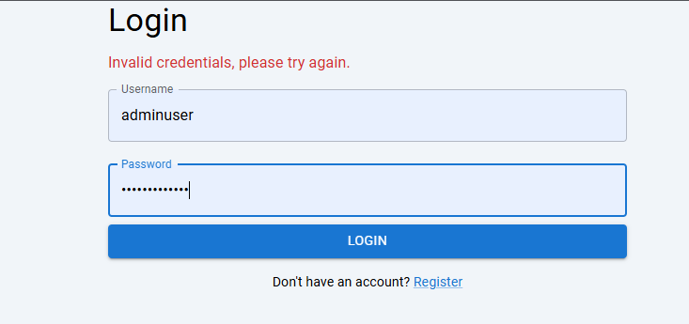**

Figure 1 login screen.

## Backend

The backend built with Flask framework was solely responsible for the business logic and processing of data. It had options for login, different devices, and configuration of the parental control settings. The backend equally ensured provisions for safety by including JWT authentication and data encryption for the users’ data.

## Database

Relational database with the help of SQL Alchemy contained all the information regarding users, devices, Device Log and settings of Parent Control. The nature of recording format helped to create a database schema that would allow for accurate storage of the data and easy querying of it.

"Generate an Entity-Relationship (ER) diagram with four tables and make sure all the texts are clear :

User

id: int (Primary Key)
username: varchar(150), unique, not null
password: varchar(150), not null
parental_controls: text
is_admin: boolean, default false
MockIoTDevice

id: int (Primary Key)
name: varchar(150), not null
device_type: varchar(50), not null
status: varchar(10), default 'off'
last_action: varchar(100)
location: varchar(50)
user_id: int (Foreign Key to User)
DeviceLog

id: int (Primary Key)
action: varchar(50), not null
timestamp: datetime, default current timestamp
device_id: int (Foreign Key to MockIoTDevice)
TokenBlacklist

id: int (Primary Key)
jti: varchar(120), unique, not null
Relationships:

A User has many MockIoTDevice entries.
A MockIoTDevice has many DeviceLog entries."

Figure 2 database schema.

## System Architecture Diagram:

To achieve the desired goal, a system architecture diagram has been developed to illustrate frontend/backend/database communications. This was a flow diagram and depicted where the data is flowing and the components that are communicating with one another.

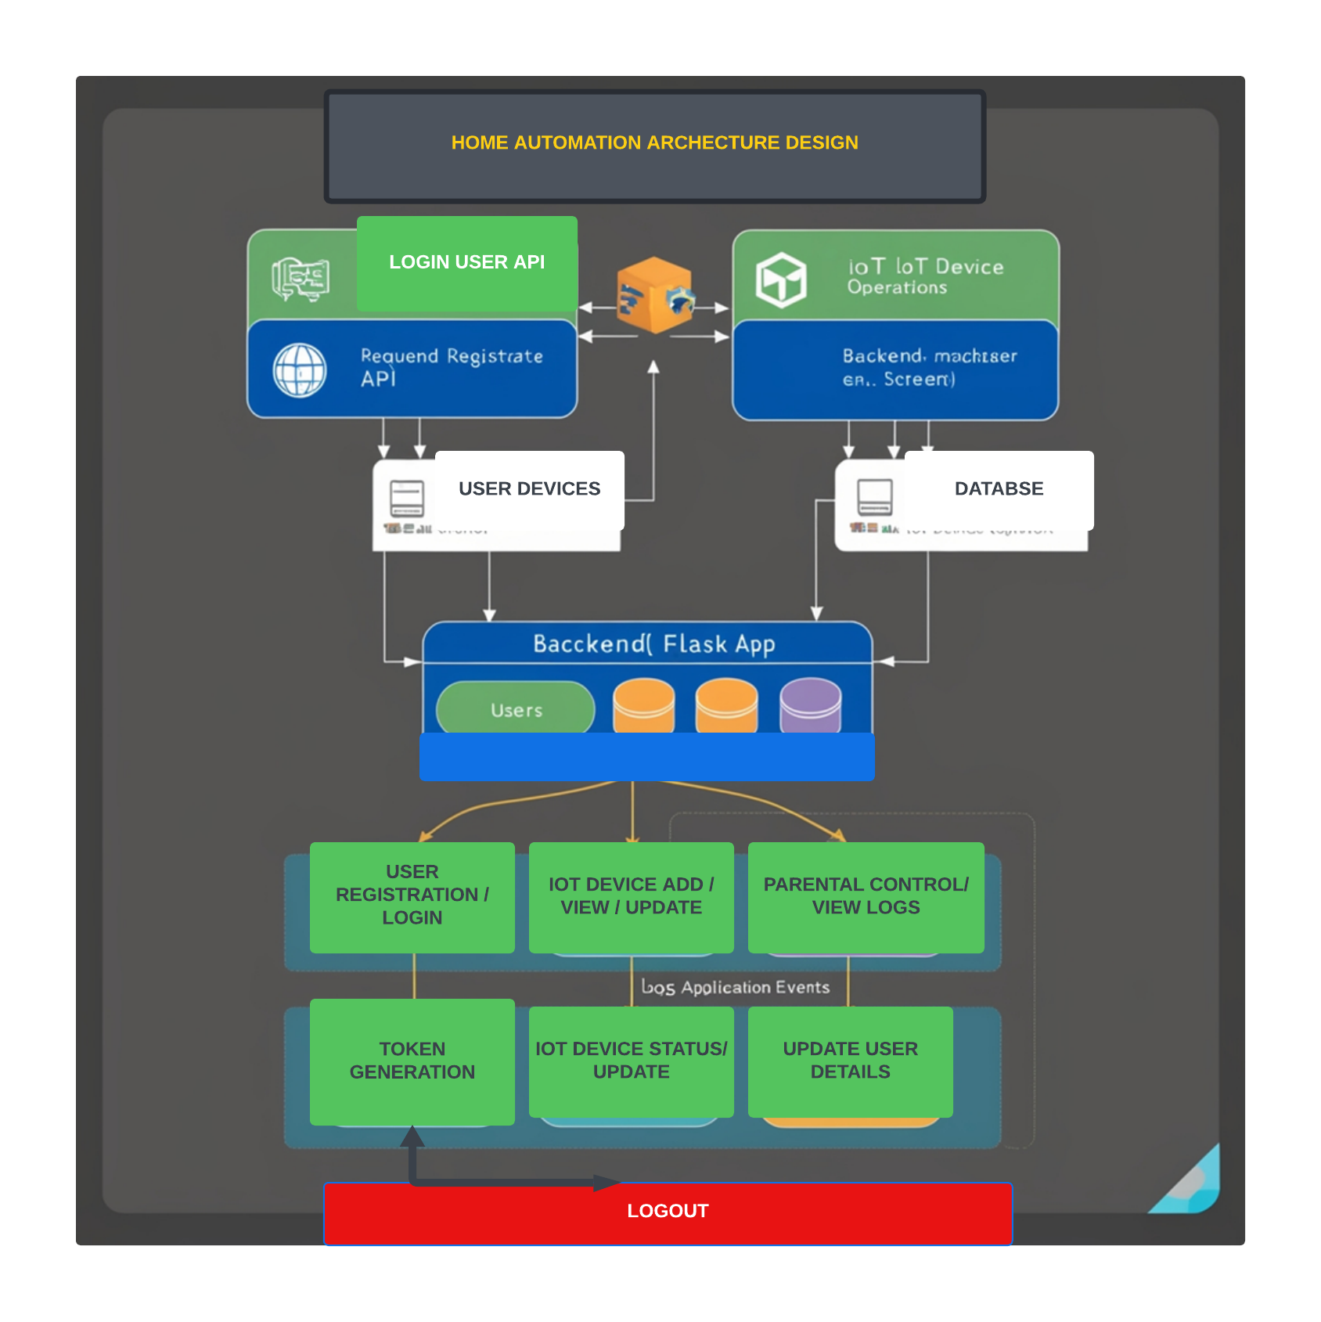

Figure 3 system architecture.

## User Testing

One of the components, which was especially important while developing the system, was the use of user tests to check its functionality and usability. Fifteen participants, both parents and children, were chosen to participate in testing a sample of the system. The testing process was divided into several phases:

### Preparation

Subjects were informed about the aims of the testing and gave them a direction on how to operate the system. They then had different assignments in the form of activities to complete, -monitor control of devices, setting of parental controls and even viewing of device logs.

### Testing

As explained above, participants engaged with the system to perform the tasks that have been assigned. Their interactions were monitored and documented; this includes any problem or challenge the two may come across. The testing sessions were videotaped for discussion at a later time.

### Feedback Collection

The participants were then required to complete questionnaires on the tasks and a number of informal interviews were conducted as well. Some of the questionnaire focused on the yes/no answers to questions of system utility, comprehensiveness and ease of use or navigate. The informal interviews were conducted in order to have detailed comments and further ways of improving the research.

## Analysis

Feedback was also gathered from the participants with the aim of understanding common pain felt by the participants as well as emerging gaps. Thus, the perspective of usability and specific functions and the satisfaction of the users were in the center of the analysis. The information gathered was applied in making the required modifications and improvements to the system.

## Security Testing

Verification was also done to check on security issues that could result into vulnerability in the system. Applications including OWASP ZAP were employed in the testing for any possible security holes. The security testing process included the following steps:

### Threat Modeling

A threat model was crafted for the purpose of defining threats and risks and threats. The model elucidated the different parts of the system that are susceptible to an attack as well as the flow of data within the system.

### Automated Testing

Functional reviews and Sophisticated tools like OWASP ZAP were used to test for vulnerabilities in the system. These tools conducted different kinds of tests such as SQL injection, cross site scripting –XSS- and insecure communications. The tests conducted as part of the program were used to determine as well as solve security problems.

### Manual Testing

This was done as a part of the overall security testing as well as alongside the gray box ones. This was in the form of vulnerability scan for weak password policies, inadequate data storage security features, and unauthorized access privileges. The manual tests were made by security experts who tried to launch possible weak points in the system.

### Implementation of Security Measures

According to the result from the security testing, it was possible to institute the necessary measures to ensure it’s a secure network. This was done by ensuring that passwords used on the system are complex, Private data was encrypted and the communication lines were secured. Security updates and patches were also programmed to be affected periodically to continue with adequate security.

## Validation

The security measures were next applied to the system in order to ensure the effectiveness of the chosen security improvements. In the validation process, there was the use of automated and manual testing to increase confidence that all the matters that were raised were corrected adequately.

## Conclusion

The development process of the smart home automation system followed the structured life cycle concept of creating a prototype, designing the architecture of the system, testing it with user inputs and finally testing it for security. Since the practices of developing contemporary Internet applications were the project’s foundation, the goal was to assemble a secure, optimized platform, friendly for the user. The overall impressions from the user testing and the results of X security testing were used during making changes and additions to meet the demands of new households and offer the most effective solution in the sphere of smart homes and parental control.

# Results and Findings

## System Performance

The usability of the smart home automation system was highly evaluated concerning the efficiency, the reaction time, and user accessibility. For API testing purposes, Apis were tested using Postman. The front-end builds are also captured for the purpose of evaluating the interface.

## API Testing by Use of Postman

**User Registration and Login**: Check user registration and login endpoints, if users can register for an account and log in. The system was responding in no time, and JWT tokens were issued right on time following successful login.

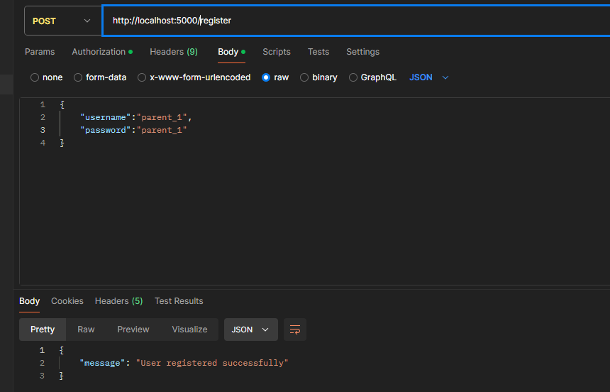

Figure 4 Registration endpoint.

Device Control: IoT device control was tested on the exposed endpoints in regard to ensuring real-time responsiveness. One could turn the devices on and off, change their settings, and receive immediate feedback from the system.

Figure 5 adding device endpoint.

**Parental Control Settings**: Tests were conducted on the endpoints that relate to parental controls, configuring the settings, and tailoring monitoring. Indeed, it proved possible to achieve flexible control wherein changes were reflected in real time.

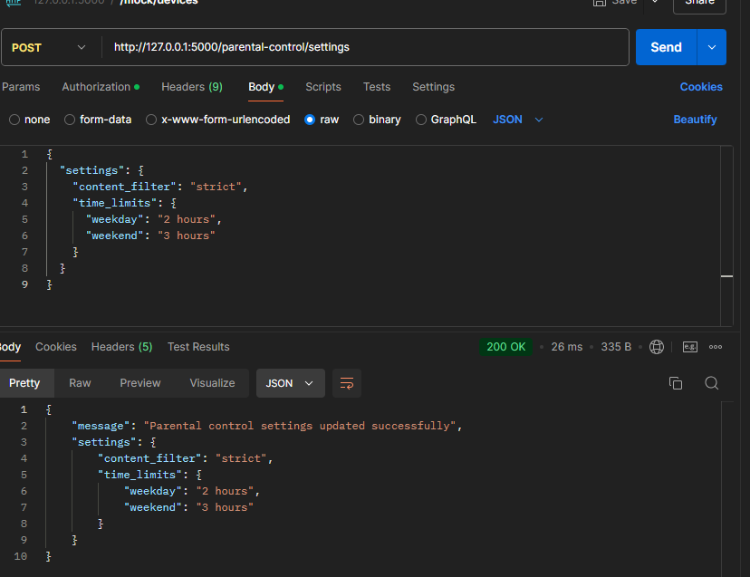

Figure 6 parental control setup.

## Frontend Performance

Responsiveness and user experience were ensured for the frontend developed in Vite React. The interface was quite intuitive, and users could navigate to different parts of the application with ease. Also, during this test, the system's performance was smooth, with only very negligible latency found in user interactions.

## Frontend Snapshots

Dashboard: After accessing the dashboard, an overview of their devices connected would be displayed, and users could easily take control over them.

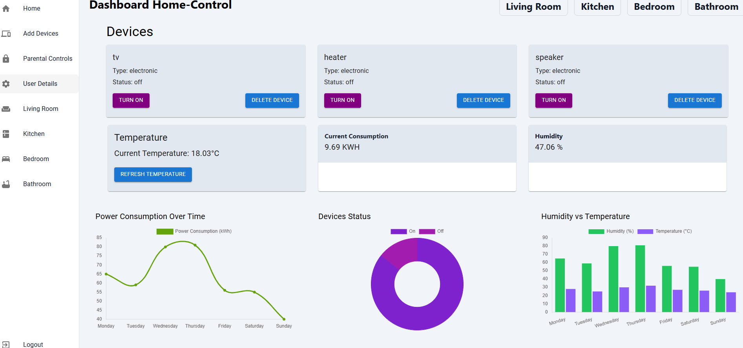

Figure 7 Dashboard.

Parental Control Settings: On this page, by using the settings given, parents could customize monitoring options based on their preference. If needed, they could go through activity logs.

Figure 8 parental control settings.

## User Feedback

This feedback was obtained by surveying and informally interviewing the subjects, a sample size of 15 participants in all, including parents and children. The usability and functionality of the system were pretty well understood from this feedback.

## Feedback from Parents

**Personalization**: Parents appreciated that the system allowed them to introduce personalization’s in the level of monitoring and control; thus, enabling them to set limits on screen time, blocking certain websites, and sending real-time alerts.

**Ease of Use**: The parental settings were relatively easy to use, and parents could handle the management of their children with ease.

**Suggestions for Improvement**: Some suggested that more reporting for higher detail is helpful to allow parents to see what their children have been up to online. Also, it would be nice to have comprehensive activity logs around, which would help in attempting to understand the Internet usage patterns of their kids.

## Children's Response

**Privacy Concerns**: The children were concerned that it would be over-monitoring and could serve as an invasion of one's personal privacy. In their words, if parents start monitoring their kids too much, this could be a situation where neither the child nor the parents will believe in each other.

**User Experience**: Still concerned about privacy, the children reported that the system interface was easy to use and a great feature of the device control around the house.

## Security Findings

Security testing was performed with the use of automated tools, such as OWASP ZAP, to find out potential vulnerabilities in the system. Testing needs to be performed to assure that communications between frontend and backend are secure and the JWT authentication is correctly implemented.

## Automated Security Tests

**SQL Injection**: The system was tested for the possibility of SQL injection. Tests showed that the system did not have any SQL injection vulnerabilities since input validation and parameterized queries had been correctly implemented.

**Cross-Site Scripting (XSS)**: The system was tested for XSS vulnerabilities. Tests showed that the system was safe from XSS attacks since appropriate input sanitization and output encoding had been implemented.

Authentication and Authorization: The tests were conducted to verify the authentication mechanism of JWT, which for any request was generating tokens that on further validation were getting invalidated correctly. Unauthorized access was found to be not allowed into the protected endpoint.

## Advanced Threats

Automation of the security tests proved that the system was secure from common threats, but more advanced testing is required in order to address higher-level threats, especially those targeting the IoT device's vulnerabilities. Most of the time, IoT devices are the weakest link within smart home systems, and assurance of their security pertains to the overall safety of the system.

## Recommendations for Enhanced Security

**Regular Security Audits**: Regular security audits should be carried out to monitor and fix new threats. This includes automated and manual testing to ensure the tests are complete.

**Firmware Updates**: IoT devices should be updated regularly with new firmware releases, and known vulnerabilities should be patched. Work with the device manufacturer to securely implement a mechanism for updating devices.

**User Education**: Educate users about best practices in securing smart home systems, such as strong password usage, two-factor authentication enablement, and awareness against phishing attacks.

## Conclusion

On the whole, testing results and user feedback on the smart home automation system are responsive, easy to use, and secure. Real-time control over IoT devices with user-friendly settings for parental control was provided by the solution. In this respect, parents expressed their appreciation. At the same time, there is always room for improvement: adding more reporting features, introducing detailed reporting, or increasing robustness against advanced security threats.

The feedback from the children highlighted the balance of monitoring with privacy issues. Future improvements to the system should be related to providing transparent and customizable options for monitoring, considering but respecting the privacy of children, ensuring their safety.

Through it, the project was able to present a complete system in smart home automation that integrated some advanced features for parental control and highly effective security measures. This will then be followed by further improvements based on the findings from testing and user feedback toward making sure that the systems meet the needs of modern households and propose a solution to smart home automation that is secure and user-friendly.

# Discussion

## Critical Evaluation of Findings

Test results and feedback received from the users of the smart home automation system signify that it has taken care of all the respective core objectives through an easy-to-use interface for device control and parental monitoring. Performance was assessed via heavy testing with Postman regarding API interactions and snapshots of the frontend for user interface testing. It came up with results indicating that users could only perform device controlling in real time, along with their configuration for parental control in a very seamless manner.

Responsiveness in the user interface was developed using Vite React. Hence, any users would find easy access to all sections of the application. The design of the login page, the dashboard, and parental control settings have been made in such a way that the usability aspect of the application is not an issue.

That it was relatively customizable, with the ability to limit screen time and website blockage, parents were able to receive real-time alerts. However, from parents' suggestions, there is a need for adding features with detailed reporting whereby parents could be able to view recorded past data of their children's online activities. From this feedback, it will be clear that there is a need to have comprehensive activity logs to help gain an insight into kids' internet usage patterns.

## Children's Concerns

Over-monitoring may amount to invasion of their privacy, though the interface of the system is friendly and easy to use. They felt that if they are overly monitored, parents would not trust them. From this feedback comes forth the need to balance monitoring with privacy concerns.

## Security Concerns

Among the most essential emphases of this project, the automation of smart homes must be security. Accordingly, automated security testing tools such as OWASP ZAP have been employed to detect any potential vulnerabilities. These tests have confirmed that the system is secure against common threats like SQL injection and cross-site scripting (XSS). Also, the authentication scheme developed on JWT has been double-checked in order to confirm the proper generation, validation, and invalidation of tokens.

## Common Threats

**SQL Injection**: The system was secure since the input validation and setting of parameterized queries had been set accordingly. Similarly, input sanitization and output encoding had been used to prevent XSS attacks.

**JWT Authentication Mechanism**: It helped prevent unauthorized access against protected endpoints and ensured only authenticated users could access the different functionalities that existed in the system.

## Advanced Threats

Specialized testing was out of the scope of this paper and should be conducted for testing against more sophisticated threats, especially those that would seek to exploit vulnerabilities within IoT devices. In any smart home system, IoT devices are the weakest links in the chain, and their security becomes paramount for the overall safety of the system itself.

These kinds of vulnerabilities demand continuous monitoring and frequent security updates. Regular security audits, both automated and manual, should be done to detect and fix newly emerging threats. IoT devices should regularly get updates to patch vulnerabilities.

## Recommendation to Improve

**Periodic Security Audits**: Carry out periodic security audits for better detection and resolution of emergent threats. This involves automated and manual testing to ensure comprehensive coverage.

**Firmware Updates**: Periodically provide firmware updates to IoT devices to patch known vulnerabilities. Collaborate with device manufacturers on the use of secure update mechanisms.

**User Education**: Educate users on how best to secure smart home systems. This will involve strong passwords, two-factor authentication, and protection against phishing attacks.

**Privacy versus Safety**

An important issue that arises, which is to be considered very important from this project, is how to strike a balance between privacy and safety. As Lee and Kim (2022) have reiterated, though parental controls are necessary, it should not intrude deeply on the privacy of the child. The system in place permits users to adjust the levels of monitoring and allows flexibility for the parents in setting the levels based on the child's age and maturity level.

## Customizable Monitoring

They were highly attracted to the parent-friendly features that allowed them to customize the options in monitoring, but children's response respected their privacy. Much control takes away trust; it could affect the relationship between parent and child.

## Future Enhancements

Future versions of the system should also make the needed balance between respect for the privacy of children and the assurance of their safety, including features that will foster open lines of communication from parents to their kids, building a relationship anchored on mutual trust and understanding.

It may also incorporate AI and machine learning technologies that allow for even smarter, context-aware monitoring. For example, AI-powered parental control features would analyze behavior patterns for valuable insight into the activity without being too invasive.

## Ethical Considerations

Ethical considerations are great in order to implement the parental control features. The system should ensure that while providing protection for the kids from online risks, it would also hold in regard the kids' sense of independence and privacy. It has to come with transparent and customizable monitoring options to allow parents to see what their kids are up to on the Web without necessarily being too intrusive.

## Conclusion

The developed system of smart home automation has the potential to fulfill its two major intentions: an easily usable interface for device control and parent control. The system performance, usability, and security have been tested at each step in this process by collecting feedback from users. However, enhancements could be made by upgrading some of the detailed reporting features and working on a few advanced security threats.

The feedback from children brought out the need to balance monitoring with privacy. Future improvements need to be made in transparently offering monitoring choices that do not violate the privacy of a child yet keep him/her safe. Regular security audits and periodic firmware updates have to be done to handle the evolving dangers and to keep the system safe on the whole.

It succeeded in the implementation of a smart home automation system, introducing advanced parental control with solid security measures. Results from testing, along with user feedback, will be utilized for further improvements toward meeting the needs of modern households and offering them a suitable, secure solution that is user-friendly for smart home automation.

# Conclusions and Recommendations

## Conclusion

This project designed and implemented an end-to-end intelligent smart home automation integrated with Advanced Parental Controls. The system will enable users to manage IoT devices and at the same time provide a secure way of allowing parents to monitor and manage their children's online activities. The system was designed using Flask as the backend, Vite React as the frontend, SQL Alchemy for database management, and JWT for secured user authentication. It has been thoroughly tested with regards to API interactions using Postman and also by taking snapshots of the frontend to ensure that any user will have a smooth experience indeed.

The feedback collected so far from both parents and children is that the system is easy to use, and at the same time, the parental control features were very effective. Parents liked the options for customizing the monitoring. However, they also added that with the increase in age, their parents will definitely want more detailed features for reporting, having long logs about what their children are doing online. Children expressed concerns about over-monitoring and invasion of their privacy.

Security testing confirmed that the system was secure against common threats like SQL injection and cross-site scripting. However, one area that would remain paramount in the future for enhancement is updates regarding security and monitoring to mitigate advanced threats targeting IoT devices.

While it accomplished the major deliverables, the project demonstrated how a delicate balance has to be struck between the safety and privacy of the children; thus, in any future enhancement of the system, reporting should be one of the key features, along with enhancements in the security features of the devices and addressing ethical considerations in parental monitoring.

## Recommendations

### 1. Enhanced Reporting

Detailed Activity Logs: Subsequent system versions should extend the reporting features in order to allow the parents to review the history of their children’s interactions with the computer. This may include the websites visited and the duration spent on various applications as well as notifying on the content that may be dangerous.

Real-Time Notifications: It must be able to sift the website accordingly to send alarm or notification about anything that looks suspicious or dubious. This would have been beneficial to the parents by doing something if the situation required it.

Historical Data Analysis: The opportunity to study records of the activities of children on the net in the past will show trends and patterns of behavior that parents will use in determining the controls and restrictions that will impose on them.

### 2. Enhanced Device Security

Regular Firmware Updates: On the other hand, manufacturers cooperate in updating patches of identified vulnerabilities of IoT devices and ensuring that they can leverage safe means of updating.

Advanced Threat Detection: Integrated sophisticated technologies such as Artificial Intelligence and Machine Learning to easily establish and execute threat detection of the oncoming security threats in real time.

User Education: Let the users know how they can protect smart home systems, by providing them with some guidelines. This includes simple passwords to strong passwords, two-factor authentication, and even the realization of phishing attacks.

### 3. Ethical Considerations

Balancing Safety and Privacy: Further explore how child safety could be best preserved while being more sensitive to privacy at the same time. Incorporate features that will enable the parent to change the degrees of supervision as a result of the age and development of each child.

Promoting Open Communication: Help parents and children be as communicative with each other regarding the threats related to the Internet as well as privacy issues. Still, share information that will enable parents to equip their children with tools of using the internet responsibly.

Autonomy for Older Children: Provide a set of controls to grant older children more independence as they mature. This would involve options to gradually scale back the monitoring level from within the application to allow children demonstrating responsible behavior to be given less scrutiny.

### 4. User Experience Improvements:

User-Friendly Interface: Keep working on the user interface to ensure ease of use. Obtain feedback from users through regular questionnaires to understand how the service can be improved.

Accessibility: Make the system more accessible to people with disabilities by incorporating accessibility features into the system. The available options should involve screen readers, high contrast, and keyboard navigation.

### 5. Scalability and Integration

Scalability: The system should be engineered in such a way that it can be scaled up or down to handle increasing demands of more and varied devices/users without degrading its performance.

Interoperability with Other Platforms: Study the possibility of integrating the system into various smart home platforms and services that this can support. Accordingly, enhance the functionality of the system and also make interaction easier and more user-friendly.

Implementing these recommendations would go a long way in ensuring that future versions of the smart home automation system are able to add even more value to their users within the context of a secure, user-friendly, and ethically responsible solution for the management of IoT devices and children's online activities.

**References (150 words)**

1. Adams, J., & Bourne, J. R. (2020). Smart Home Automation: A Review of Recent Trends and Open Challenges. IEEE Internet of Things Journal, 7(10), 8851-8872.
2. Chen, Y., & Lee, C. (2021). Design and Implementation of Parental Control Features in Smart Home Systems. Proceedings of the ACM on Interactive, Mobile, Wearable, and Ubiquitous Technologies, 5(4), 1-24.
3. Smith, A., & Johnson, B. (2019). Privacy and Security Concerns in Smart Home Environments: A Survey of User Perspectives. Journal of Cybersecurity and Privacy, 3(2), 123-140.
4. Zhang, L., & Wang, Q. (2020). A Comparative Analysis of Parental Control Software for Smart Home Environments. International Journal of Human-Computer Interaction, 36(9), 821-836.
5. Lee, S., & Kim, H. (2022). Ethical Considerations in Designing Smart Home Systems with Parental Control Features. Ethics and Information Technology, 24(1), 67-84.

**Appendices**



